1.Matrix Multiplication

Code:

#include<stdio.h>

int main()

{

int a[10][10],b[10][10],mul[10][10],i,j,r,c,k;

printf("enter the nuumber of rows");

scanf("%d",&r);

printf("enter the number of columns");

scanf("%d",&c);

printf("enter the elements of first matrix");

for(i=0;i<r;i++)

{

for(j=0;j<c;j++)

{

scanf("%d",&a[i][j]);

}

}

printf("enter the elements of the second matrix");

for(i=0;i<r;i++)

{

for(j=0;j<c;j++)

{

scanf("%d",&b[i][j]);

}

}

printf("the product of matrices is\n");

for(i=0;i<r;i++)

{

for(j=0;j<c;j++)

{

mul[i][j]=a[i][j]*b[i][j];

}

}

for(i=0;i<r;i++)

{

for(j=0;j<c;j++)

{

printf("%d\t",mul[i][j]);

}

printf("\n");

}

return 0;

}

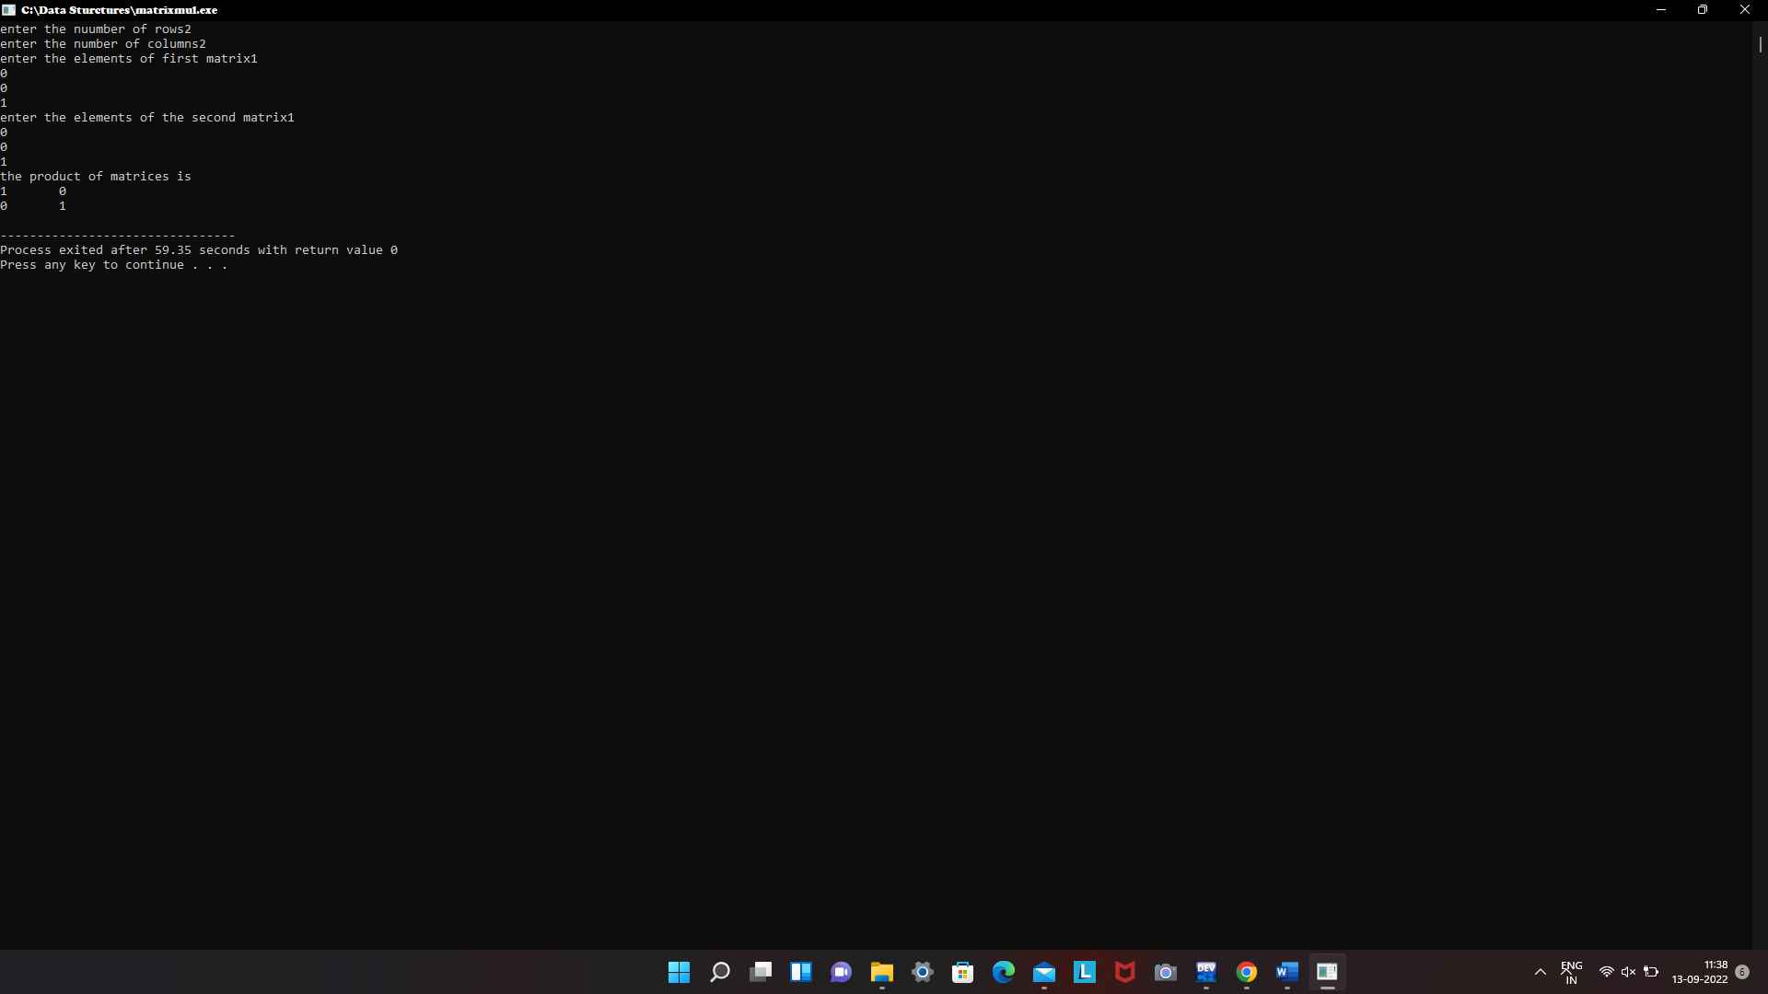

2.Finding Number Of Odd And Even Numbers

Code:

#include<stdio.h>

int main()

{

int a[100],n,i,odd_count=0,even_count=0;

printf("Enter array size:");

scanf("%d",&n);

printf("Enter the elements:");

for(i=0;i<n;i++)

{

scanf("%d",&a[i]);

}

for(i=0;i<n;i++)

{

if(a[i]%2==0)

{

even_count++;

}

else

{

odd_count++;

}

}

printf("Number of even numbers:%d\n",even_count);

printf("Number of odd numbers:%d",odd_count);

return 0;

}

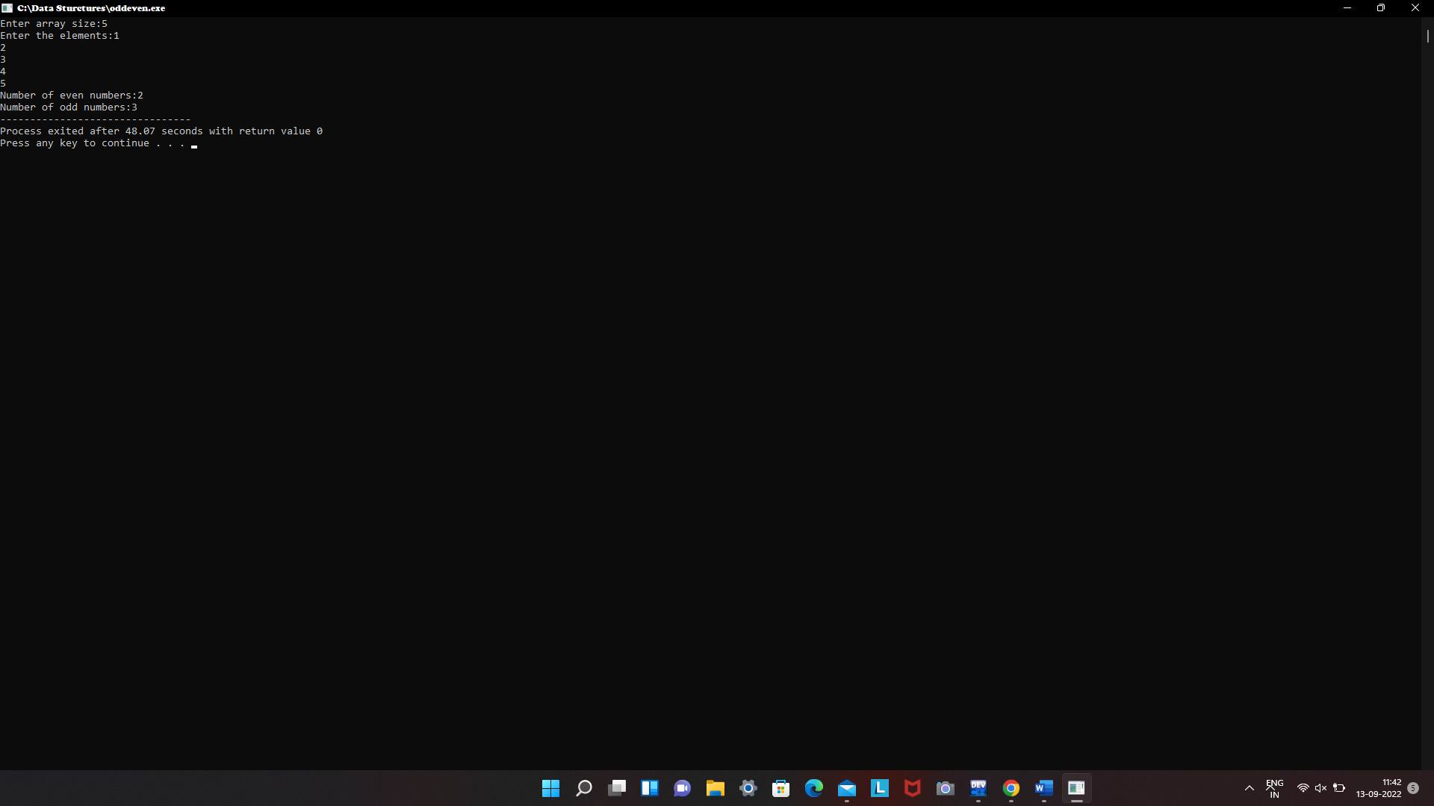

3.Factorial Using Recursion

Code:

#include<stdio.h>

long int multiplyNumbers(int n);

int main()

{

int n;

printf("Enter a positive integer: ");

scanf("%d",&n);

printf("Factorial of %d = %ld", n, multiplyNumbers(n));

return 0;

}

long int multiplyNumbers(int n)

{

if (n>=1)

return n*multiplyNumbers(n-1);

else

return 1;

}

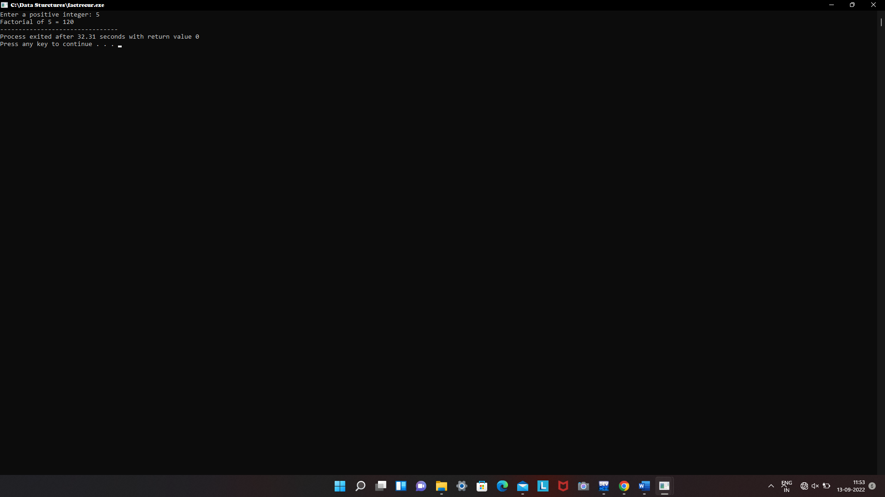

4.Factorial Without Recursion

Code:

#include<stdio.h>

int main()

{

int i,n,fact=1;

printf("Enter the number:");

scanf("%d",&n);

for(i=1;i<=n;i++)

{

fact=fact*i;

}

printf("Factorial=%d",fact);

return 0;

}

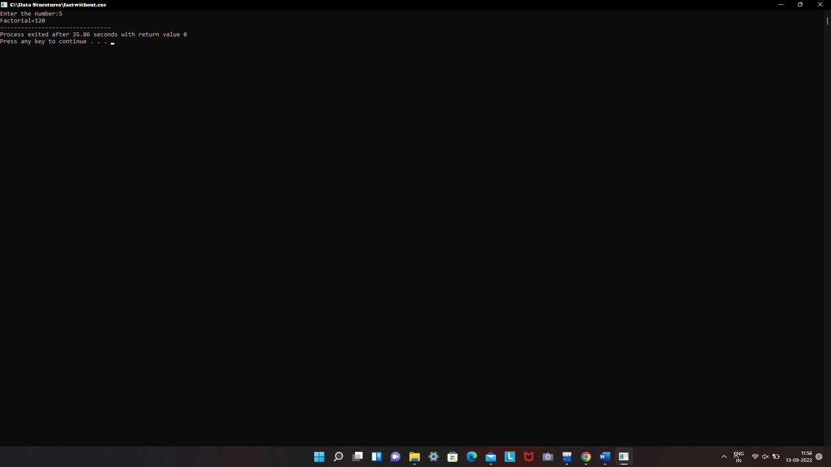

5.Fibonacci Without Recursion

Code:

#include<stdio.h>

int main()

{

int first=0, second=1, i, n, sum=0;

printf("Enter the number of terms: ");

scanf("%d",&n);

printf("Fibonacci Series:");

for(i=0 ; i<n ; i++)

{

if(i <= 1)

{

sum=i;

}

else

{

sum=first + second;

first=second;

second=sum;

}

printf(" %d",sum);

}

return 0;

}

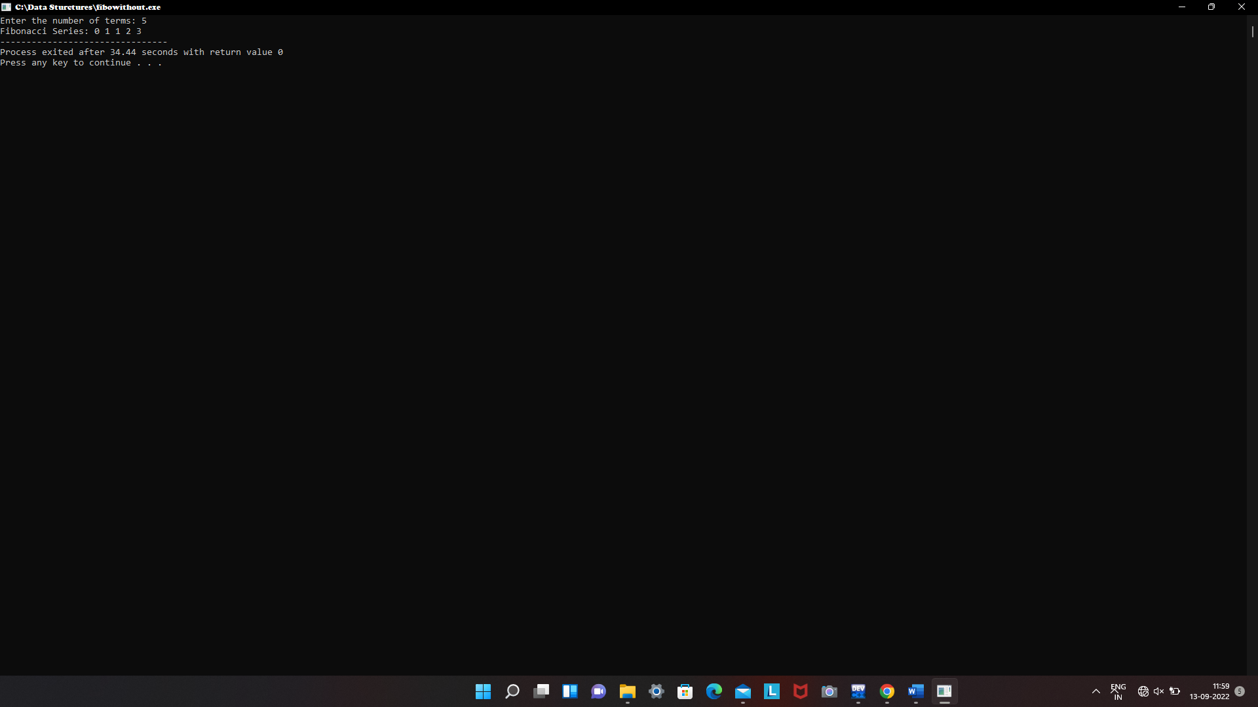

6.Fibonacci With Recursion

Code:

#include<stdio.h>

int fibonacci(int);

int main()

{

int n, i;

printf("Enter the number of element you want in series :\n");

scanf("%d",&n);

printf("fibonacci series is : \n");

for(i=0;i<n;i++)

{

printf("%d ",fibonacci(i));

}

return 0;

}

int fibonacci(int i)

{

if(i==0)

{

return 0;

}

else if(i==1)

{

return 1;

}

else

{

return (fibonacci(i-1)+fibonacci(i-2));

}

